Utilising Threat Intelligence in Sentinel

# Integrating threat intelligence into Sentinel

TI can be integrated by:

* Use Data connectors to various TI platforms to import threat intelligence into sentinel.
* View and manage the imported threat intelligence logs and the new TI area of sentinel.
* Use the built-in Analytics rule templates to generate security alerts and incidents using your own imported TI
* Visualise critical information about your TI in Sentinel with the TI workbook
* 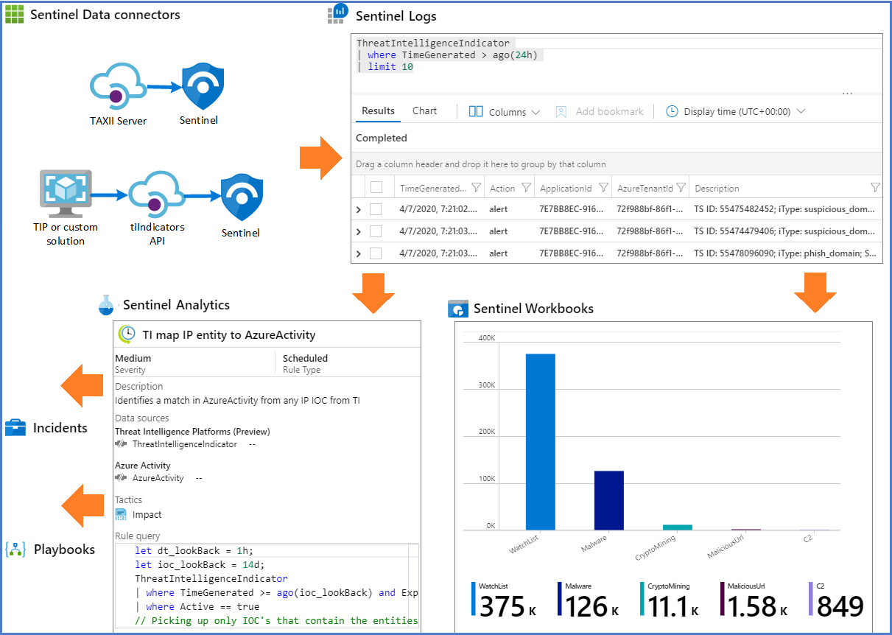Perform threat hunting with your imported threat intelligence.

## Indicator tagging

Tagging indicators is an easy way to group them to make them easier to find. Typically you might apply a tag to indicators related to a particular incident or indicators representing threats from a known actor or a well-known attack campaign. We can tag them individually or multi-select indicators and tag them all at once.